
School of Science and Technology

Electronic Devices and Materials Technology ENGG10031
Academic Year 2022-2023

Lab 6: Transistors I – BJT

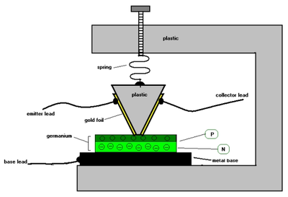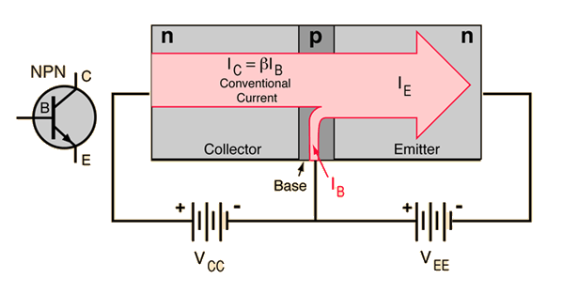

Objectives
- Experiencing different transistors and pin identification
- Studying input characteristics of BJTs

Equipment and materials
Each group will have
- Digital multimeter (DMM) (Keithley 2110)
- 1 2N2222A transistor
- 1 ZTX689B transistor
- 1 ZTX 689B transistor
- 1 BC327 transistor
- 1 BC337 transistor
- 1 TIP31C transistor
- Breadboard
- DC power supply (Keithley 2231A)
- Connection leads

Transistors
A transistor is one of the most useful semiconductor device. This 3-pin device has various applications such as amplification, switching, and logic gates. This is the building block of many complicated electronic components such as microprocessors.
There are different types of transistors including Bipolar Junction Transistors (BJT), Field Effect Transistors (FET), and Metal Oxide Field Effect Transistors (MOSFET). You will get two BJT and one MOSFET transistor.
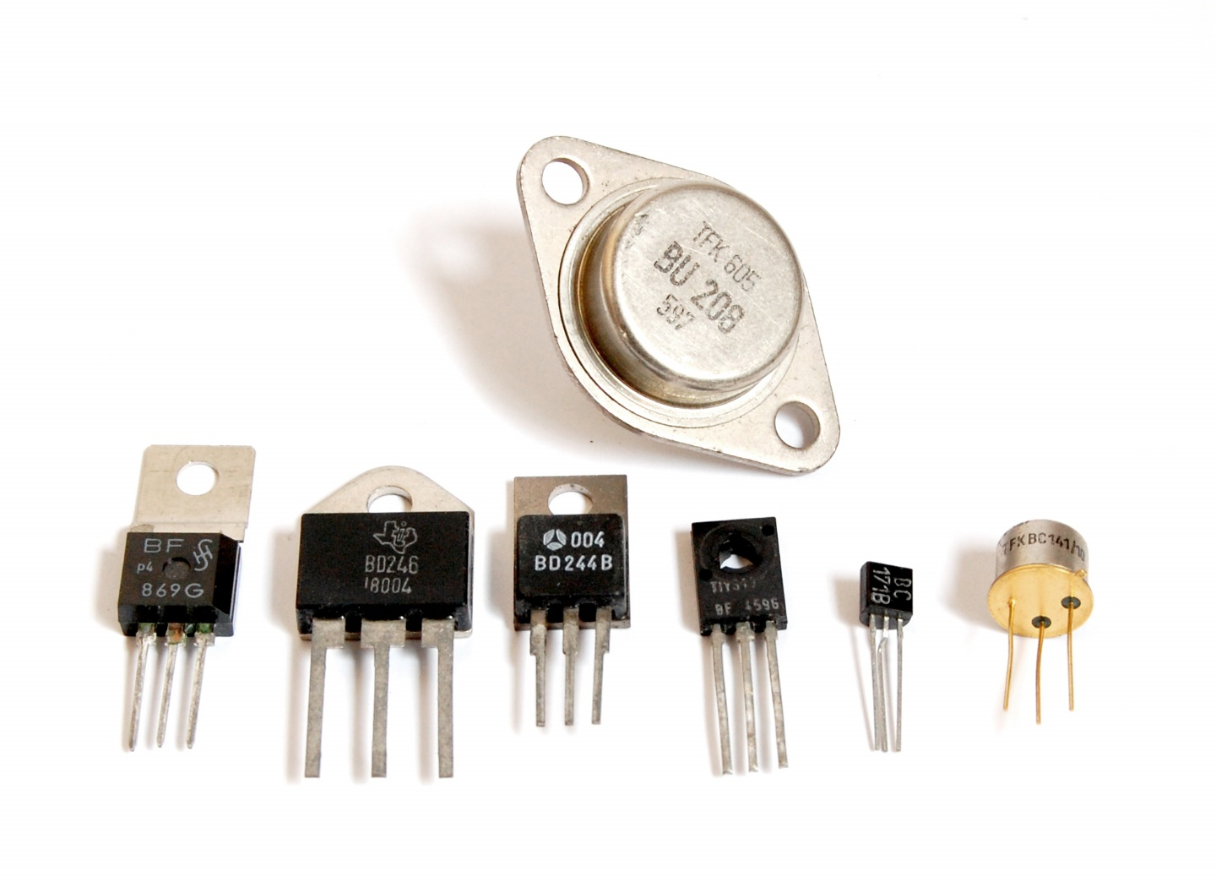
Figure 1. Transistors
Bipolar Junction Transistors (BJT)
The three terminals of a BJT transistor are identified as base (B), emitter (E) and collector (C). There are two types of BJTs called NPN and PNP transistors. A NPN transistor is constructed by sandwiching a p-type semiconductor between two n-type semiconductors. In contrast, a PNP transistor is constructed by sandwiching an n-type semiconductor between two p-type semiconductors. Therefore, BJT transistors have two PN junctions which behave like diodes. The circuit symbols of those two types are shown in Figure 2 and a simple double-diode analogy for BJTs are shown in Figure 3.
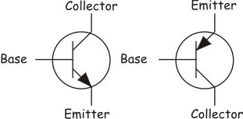
(a) (b)
Figure 2. Circuit symbol of transistors; (a) NPN and (b) PNP

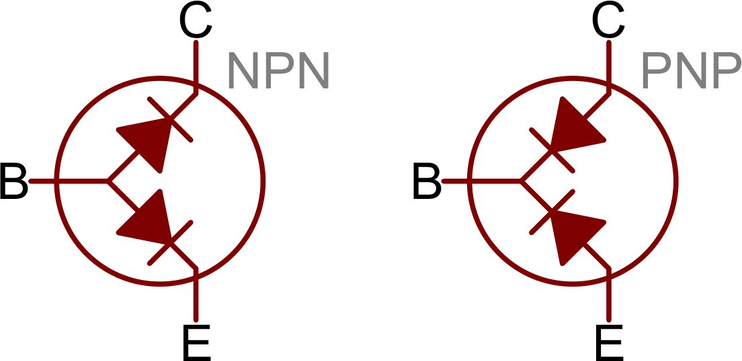
Figure 3. Double-diode analogy of BJT transistors

Input characteristics of a transistor
A transistor is a two-port device. It can take an input and deliver an output. For both input and output, two terminals are needed. This can be done in a transistor by making one of the three terminals common, namely common emitter (CE) configuration, common base (CB) configuration, and common collector (CC) configuration. In each of these configurations, the transistor characteristics are unique. The common emitter configuration is used most widely because it provides voltage, current and power gains. In this experiment, you will focus on the common emitter configuration, as shown in Figure 4.
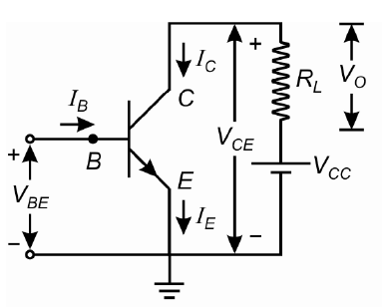
Figure 4 Common emitter configuration
The most important characteristics of transistor in any configuration are input and output characteristics. The Input Characteristics is the curve between input current I_{B} and input voltage V_{BE} at constant collector emitter voltage V_{CE}. The input characteristic resembles a forward biased diode curve. After cut in voltage the I_{B} increases rapidly with small increase in V_{BE}. It means that dynamic input resistance is small in common emitter configuration. The dynamic input resistance is the ratio of change in V_{BE} to the resulting change in base current at constant collector emitter voltage, which is given by ΔV_{BE} / ΔI_{B}.
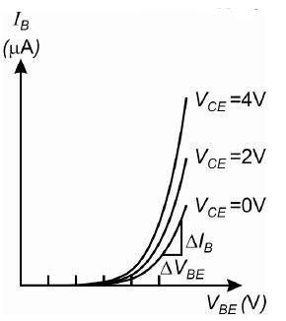
Figure 5 Typical input characteristics of a transistor in common emitter mode.


Tasks 1

Double-diode analogy of the BJT
You are provided with three different transistors. Your task is to identify the base terminal of each transistor and whether they are of NPN or PNP.

Method:
- Use the diode function (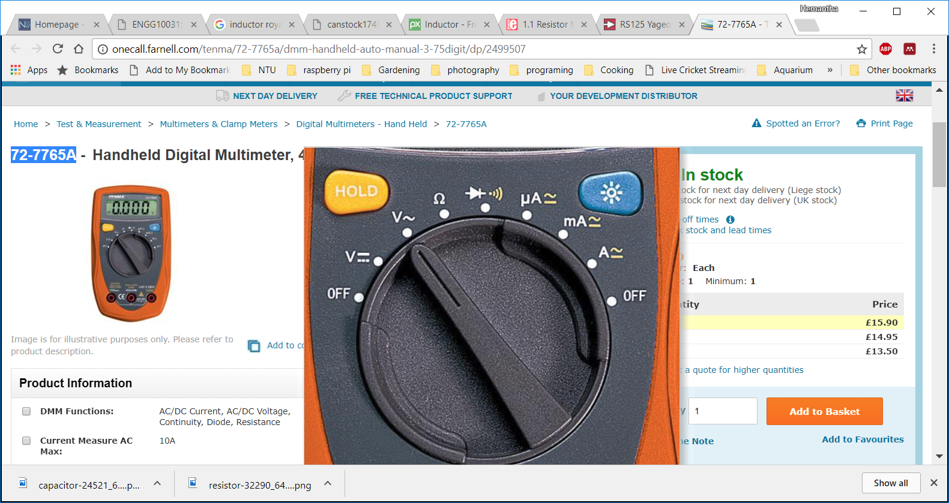) of the DMM to measure the voltage drop across terminals and complete the Table 1 below.
The pin numbering convention is depicted in Figure 4. Make sure to use the DMM probes in the correct order. For example ‘12’ means ‘measure the voltage drop across terminal number 1 and terminal number 2 by keeping positive probe (red probe) on the terminal number 1 and negative probe (black probe) on the terminal number 2. The leftmost terminal when the printed side (or the flat side) is facing up is the terminal number 1.
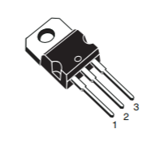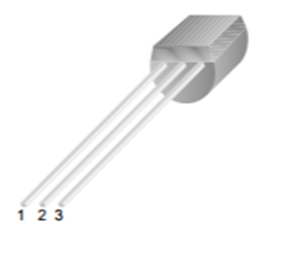
Figure 6. Pin numbering convention

- Take the same set of measurements for the 4th transistor to complete the Table 2.

Table 1. Built-in junction voltage of the first three transistors
Part number | Voltage drop across the terminals (V) |  |  |  |  |  | Base terminal? | NPN or PNP?
 | 12 | 21 | 23 | 32 | 31 | 13
2N2222A
ZTX689B
ZTX751
BC327
BC337
TIP31C
- Use a search engine to locate the datasheet of the BJT transistor KSP2222. Complete the table using the datasheet.
Table 3. KSP2222 parameters
Parameter | Value (unit)
Absolute maximum collector-base voltage ($V_{CBO}$)
Absolute maximum emitter-base voltage ($V_{EBO}$)
Minimum DC current gain ($β$ or $h_{FE}$) when $V_{CE}=10 V$ and $I_{C}=1 mA$


Tasks 2

Input characteristics
In this task, you will plot the input characteristics of a transistor under common emitter configurations.
Figure 7. Circuit diagram

Procedures:
- Make the circuit connection as shown in the circuit diagram Figure 7 using the BC337-40 NPN transistor. Note that you will need to use two channels of the power supply to provide voltage VBB and voltage VCC. Make sure the terminals of the transistor are connected into the circuit correctly.
- Utilise the DMM to measure the current flow through the resistor R1=100k by serios connection with the resistor. Set the DMM to measure current. Utilise the DMM to measure the voltage V_{BE}, and the voltage V_{CE} by parallel connection.
- Set the voltage V_{CE} = 2 V by adjusting VCC and measure V_{CE} simultaneously. Set V_{BB} based on the value in Table 4, measure I_{B} and V_{BE} and fill in Table 4. Repeating the procedures and fill in the rest values of Table 4.
Note:
- Voltage can be set by clicking the “V-Set” knob and then typing in the values using number pads or using the knob.
- To maintain a constant V_{CE}, you will need to adjust VCC for each value of V_{BB}.
- Voltage needs to be measured by parallel connection of the DMM to the circuit. Click on “DCV” to set the DMM to measure voltage. Use the top right red port and right black port for the voltage measurement.
- Current needs to be measured by series connection of the DMM to the circuit. You can do this by removing the wire that connects the resistor and the diode and replacing it with the DMM. Click on “SHIFT” and then “DCV” to set the DMM to measure current. Use the white “3A” port and right black port for the current measurement.
- Similarly, set the voltage V_{CE} = 3 V and vary I_{B} with the help of V_{BB} and measure V_{BE}, fill in Table 4.
- Plot graph of I_{B} vs V_{BE} using excel or Matlab.
- Evaluate dynamic input resistance which is the ratio of change in VBE to the resulting change in base current at constant collector emitter voltage. It is given by ΔV_{BE} / ΔI_{B}
Note: The reciprocal of the slope of the linear part of the characteristic gives the dynamic input resistance of the transistor.

Results:
Table 4 Input characteristics
V_{BB} | V_{CE}=2V |  | V_{CE}=3V
 | V_{BE} (V) | I_{B} (µA) | V_{BE} (V) | I_{B} (µA)
0.1
0.2
0.3
0.4
0.5
0.6
0.7
0.8
0.9
1
1.5
2
2.5
3
3.5
4
4.5
5

Graph of I_{B} vs V_{BE:}
Dynamic input resistance: .

Homework

- Learn how transistor pin configurations are identified. Identify the pin configuration of KSP2222, BC3272, and TIP31C transistors and complete the Table 3. Follow the given example and the pin numbering convention is as shown in Figure 4.
Table 5. Pin configuration
Transistor | Pin configuration
 | 1 | 2 | 3
TIP41C | Base | Collector | Emitter
KSP2222
BC3272
TIP31C

- Explain reason for the observed difference between the first three and the fourth transistor tested in Task 1.

